**INSURESCAN MGA LLC**

**1716 Catherine Court, Suite 1D**

**Auburn, AL 36830**

# VEHICLE INSPECTION FORM

**Original Policy Period**

**Policy Number Policy Type Inception Expiration**

<POLICY NUMBER>ALABAMA PRIVATE PASSENGER <INCEPTION> <EXPIRATION> GATEWAY INS. CO.

**Named Insured(s) and Garaging Address: For more information please contact:**

<NAMED INSURED OR INSUREDS> <AGENCY NAME>

<NAMED INSURED ADDRESS1> <AGENCY ADDRESS1>

<NAMED INSURED ADDRESS2> <AGENCY ADDRESS2>

**One form per vehicle on policy is required.**

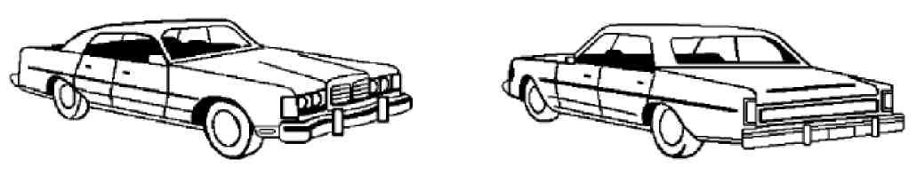

**-Please indicate on the above car the location of any old damage. Use an “S” for any scratches or an “X” for any broken glass or damaged panel.**

**-Insured may submit an MSO/BOS or complete a self-inspection signed by the agent and insured, as long as no damage is present on the vehicle.**

**-If damage is present, two photos are required to be submitted with the application along with agent and insured signatures.**

## Vehicle #__________________ Year______________ Make/Model________________________________________

VIN #__________________________________________

License Plate - State & #  **_______________________________** Odometer Reading

Vehicle Condition: **□** Excellent **□** Good **□** Fair **□** Poor

Describe any damage on the vehicle including which panel is involved: ________________________________________

## ________________________________________________________________________________________________

X_________________________________________________ X__________________________________________

Agent Printed Name Applicant Printed Name

X_________________________________________________ X__________________________________________

Signature of Agent Date Signature of Applicant Date

## AL010-112021 INSURED COPY 1